> install.packages("ggplot2")
Installing package into ‘C:/Users/admin/AppData/Local/R/win-library/4.3’
(as ‘lib’ is unspecified)

There is a binary version available but the source version is later:
binary source needs_compilation
ggplot2 3.5.1 3.5.2 FALSE

installing the source package ‘ggplot2’

trying URL 'https://cran.rstudio.com/src/contrib/ggplot2_3.5.2.tar.gz'
Content type 'application/x-gzip' length 3580451 bytes (3.4 MB)
downloaded 3.4 MB

* installing *source* package 'ggplot2' ...
** package 'ggplot2' successfully unpacked and MD5 sums checked
** using staged installation
** R
** data
*** moving datasets to lazyload DB
** inst
** byte-compile and prepare package for lazy loading
** help
*** installing help indices
*** copying figures
** building package indices
** installing vignettes
** testing if installed package can be loaded from temporary location
** testing if installed package can be loaded from final location
** testing if installed package keeps a record of temporary installation path
* DONE (ggplot2)

The downloaded source packages are in
‘C:\Users\admin\AppData\Local\Temp\Rtmpe67MDB\downloaded_packages’

Enter the values separated by space:> val<-scan()
1: 1
2: 2
3: 3
4: 4
5: 5
6:
Read 5 items
> cat(val)
1 2 3 4 5

x<-c("A","B","C","D","E")
y<-c(1,2,3,4,5)
barplot(y,names.arg = x,col = blues9)

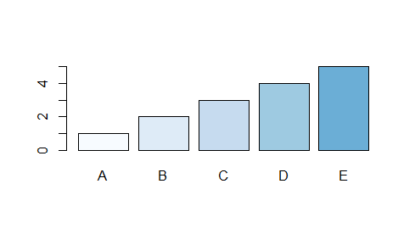

y<-c(1,2,3,4,5)
pie(y)
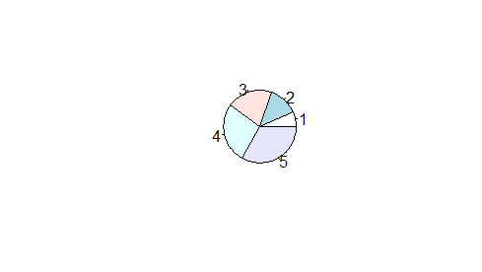

c(10:50)
[1] 10 11 12 13 14 15 16 17 18 19 20 21 22 23 24 25 26 27 28 29 30 31 32 33 34 35 36 37 38 39 40 41
[33] 42 43 44 45 46 47 48 49 50

seq(50,100)
[1] 50 51 52 53 54 55 56 57 58 59 60 61 62 63 64 65 66 67 68 69 70 71 72 73
[25] 74 75 76 77 78 79 80 81 82 83 84 85 86 87 88 89 90 91 92 93 94 95 96 97
[49] 98 99 100

2*5+10-2**4/2
[1] 12

